**Student Name: Shinde Smita Shahaji Branch: CSE-IOT**

**UID: 20BCS4643 Section/Group: B**

**Date of Performance:04/30/2021 Subject Name: Digital electronics lab**

**Aim**

**Design of a Shift Register Circuit (IC 74HC595) with Manual Pushbutton Control.**

**Task to be done**

*(Objective of the task to be explained)*

using IC 74HC595 8-bit shift register designing a circuit diagram and demonstration purposes and sees how shift registers work.

**Requirements**

*(Hardware and software requirements)*

# Software –

Tinker cad.

# Hardware –

|  |  |  |
| --- | --- | --- |
| sr.no | Apparatus | Quantity |
| 1. | 74HC595 IC | 1 |
| 2. | Connecting wires | As per requirement |
| 3. | Led | 8 |
| 5. | Breadboard | 1 |
| 6. | 1kohm resistance | 8 |
| 7. | Arduino-uno | 1 |

**Circuit diagram/ Block diagram***(Insert circuit diagram here)*

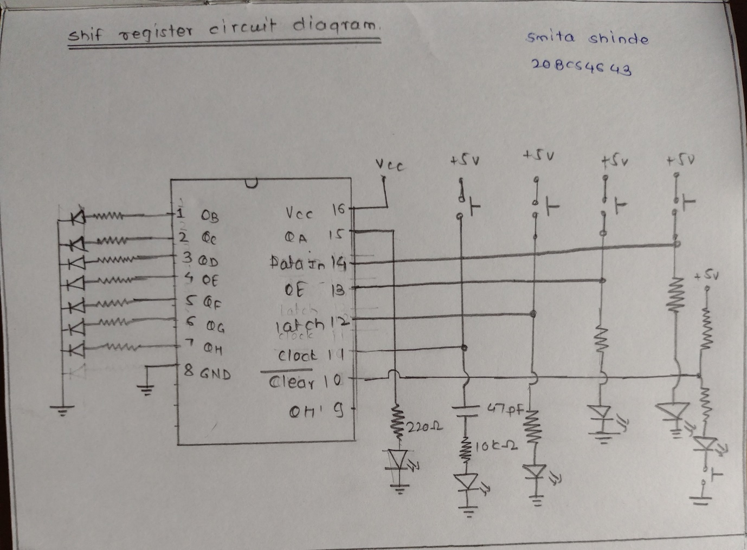

Circuit diagram on tinker cad

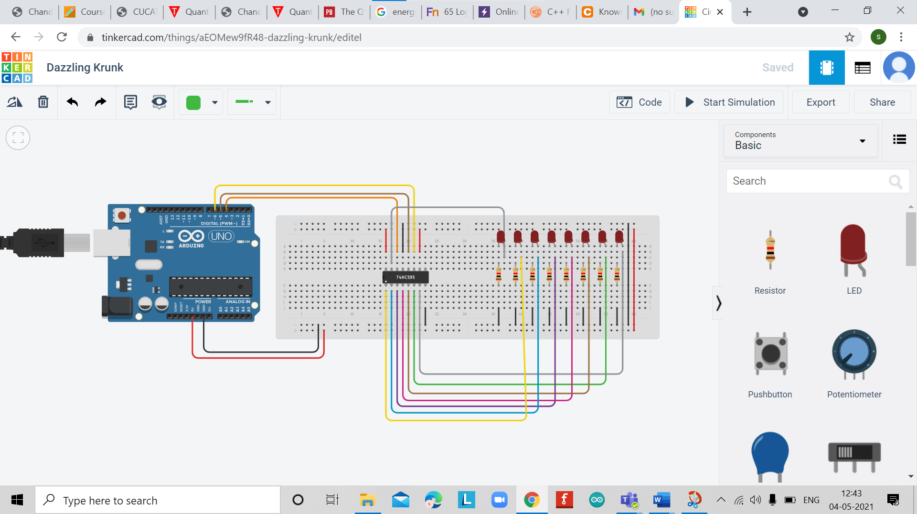

**Simulation Results:**

*(Insert simulation results )*

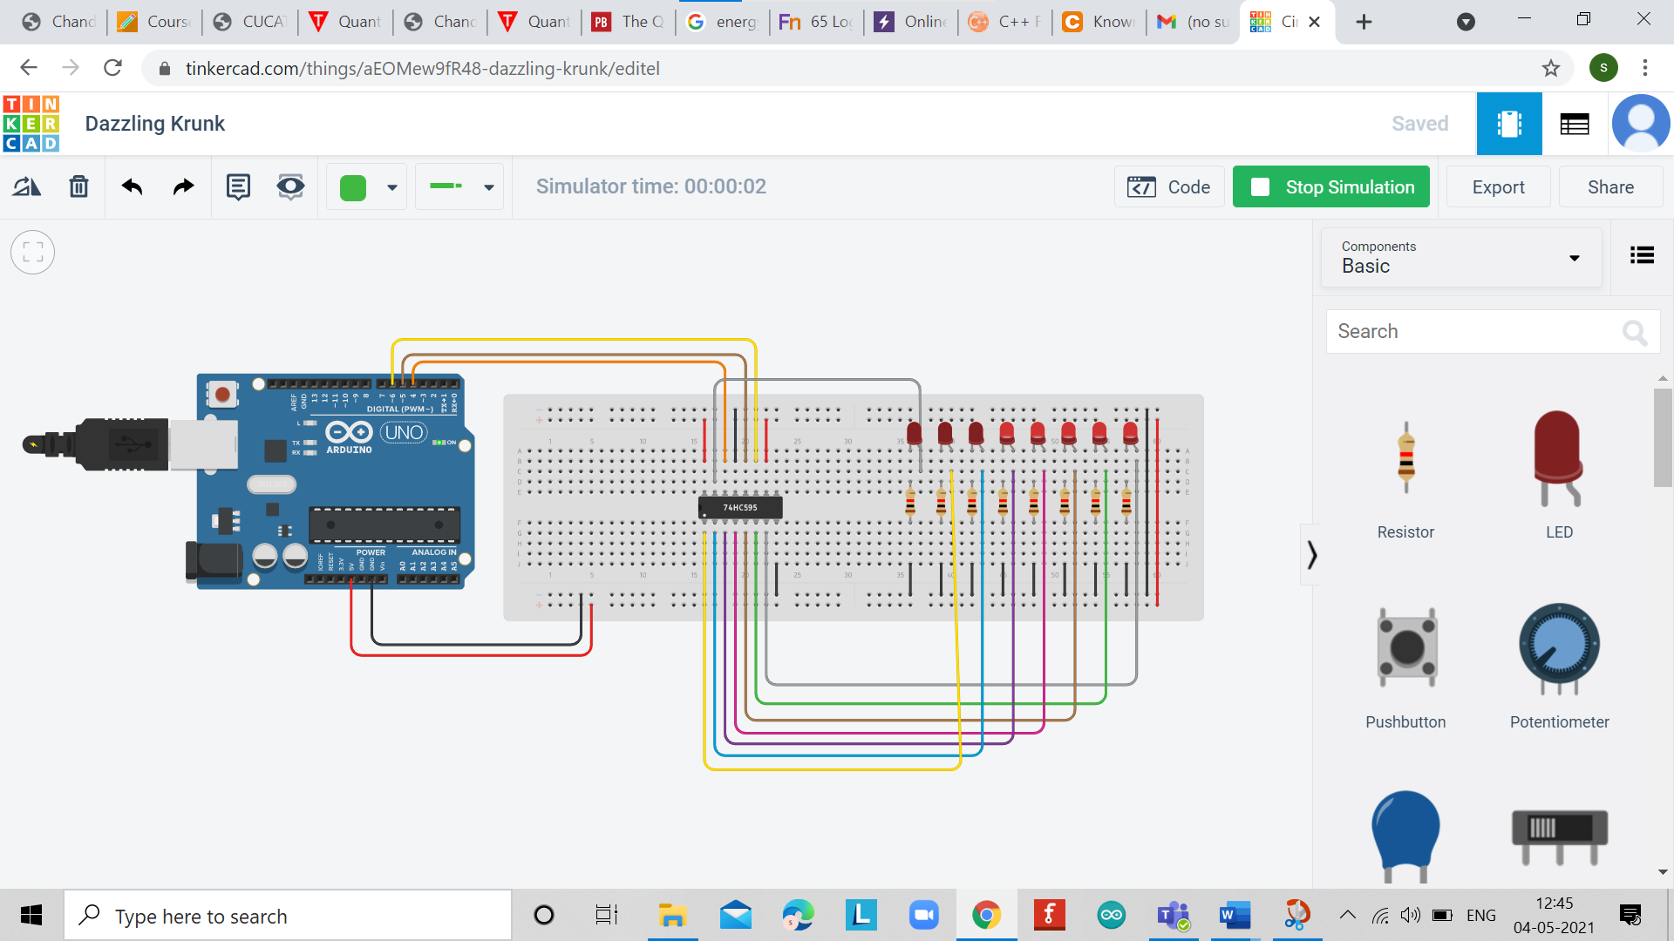

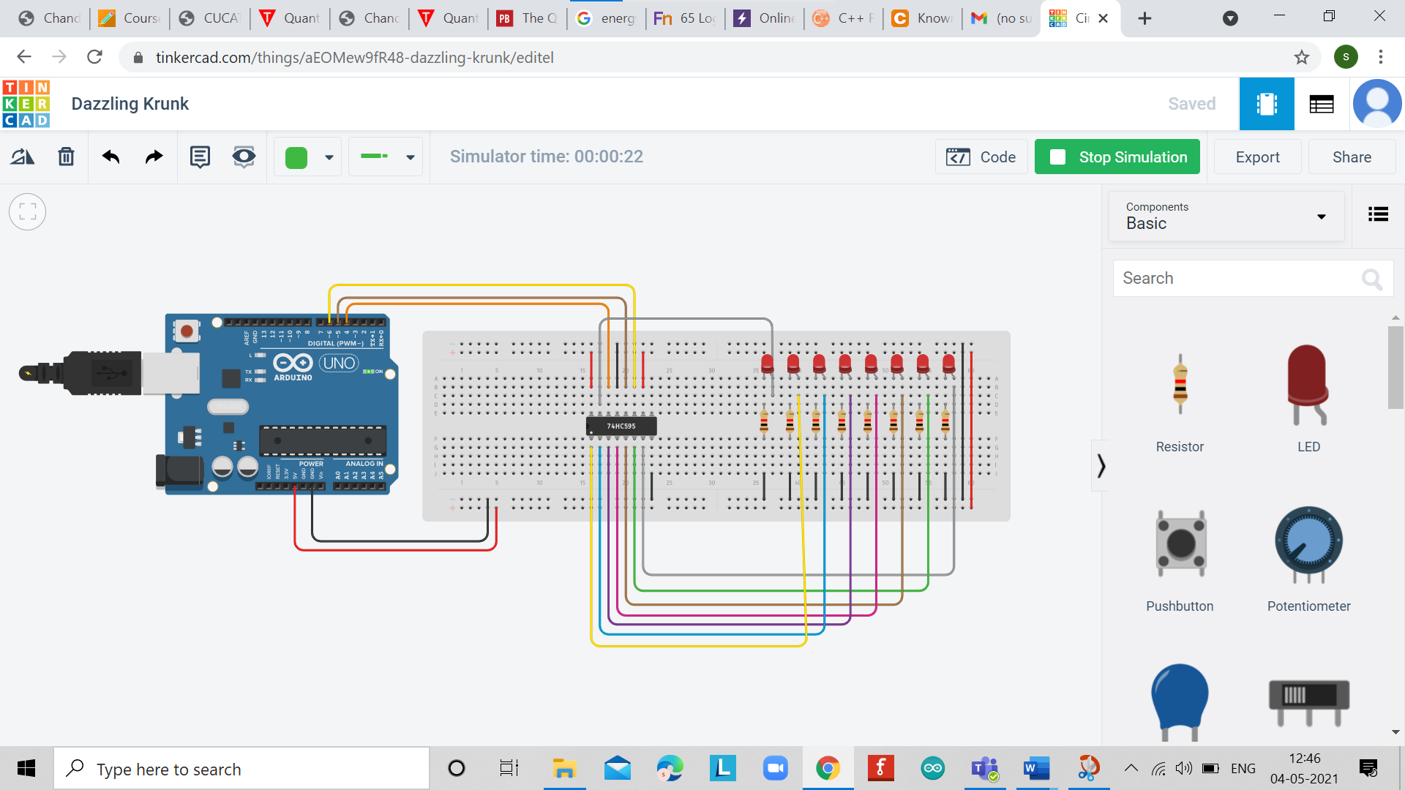

**Concept used**

*(Point out the concepts used in order to design the solution)*

* For the glowing of led we need the clock to must be HIGH in order to transfer bits to the storage register. If the serial data input line is LOW while we press the clock pushbutton.
* if 0 is transferred in to the storage register. If the serial data input line is HIGH while we press the clock pushbutton, then a 1 is transferred into the storage register.
* If you press down the clock pushbutton 8 times while the clock is HIGH, we will transfer 8 1s into the storage register.

* According to this working of clock pushbutton and serial data pin we using the input clock is high and 1st led is glow and after 500 milli-second delay 2nd led will glow and so on till 8th led this scenario is following and again shifted to 1st led after the 8th led. And this work is going on when we start the simulation.

**Learning/ observation**

*(Observations made during the experiment and learnings for future reference)*

1. The 595 has two registers (which can be thought of as “memory containers”), each with just 8 bits of data. The first one is called the Shift Register. The Shift Register lies deep within the IC circuits, quietly accepting input.
2. Whenever we apply a clock pulse to a 595-  The bits in the Shift Register move one step to the left. For example, Bit 7 accepts the value that was previously in bit 6, bit 6 gets the value of bit 5 etc.
3. Bit 0 in the Shift Register accepts the current value on DATA pin. At the rising edge of the pulse, if the data pin is high, then a 1 gets pushed into the shift register. Otherwise, it is a 0.
4. On enabling the Latch pin, the contents of Shift Register are copied into the second register, called the Storage/Latch Register. Each bit of the Storage Register is connected to one of the output pins QA–QH of the IC, so in general, when the value in the Storage Register changes, so do the outputs.

**Troubleshooting**

*(Problems encountered and how did you solved those)*

During designing no problem is encounter but when I start the simulation till the 7th led all working good and well and when the input goes to 8th led the IC 74HC595 is being blast but I can’t find it any wrong connections I rechecked all the connections but everything is fine but the 8th one register having resistance in m-ohm that why its current flowing is high when I reset it again into k-ohm its working properly and problem has been solved

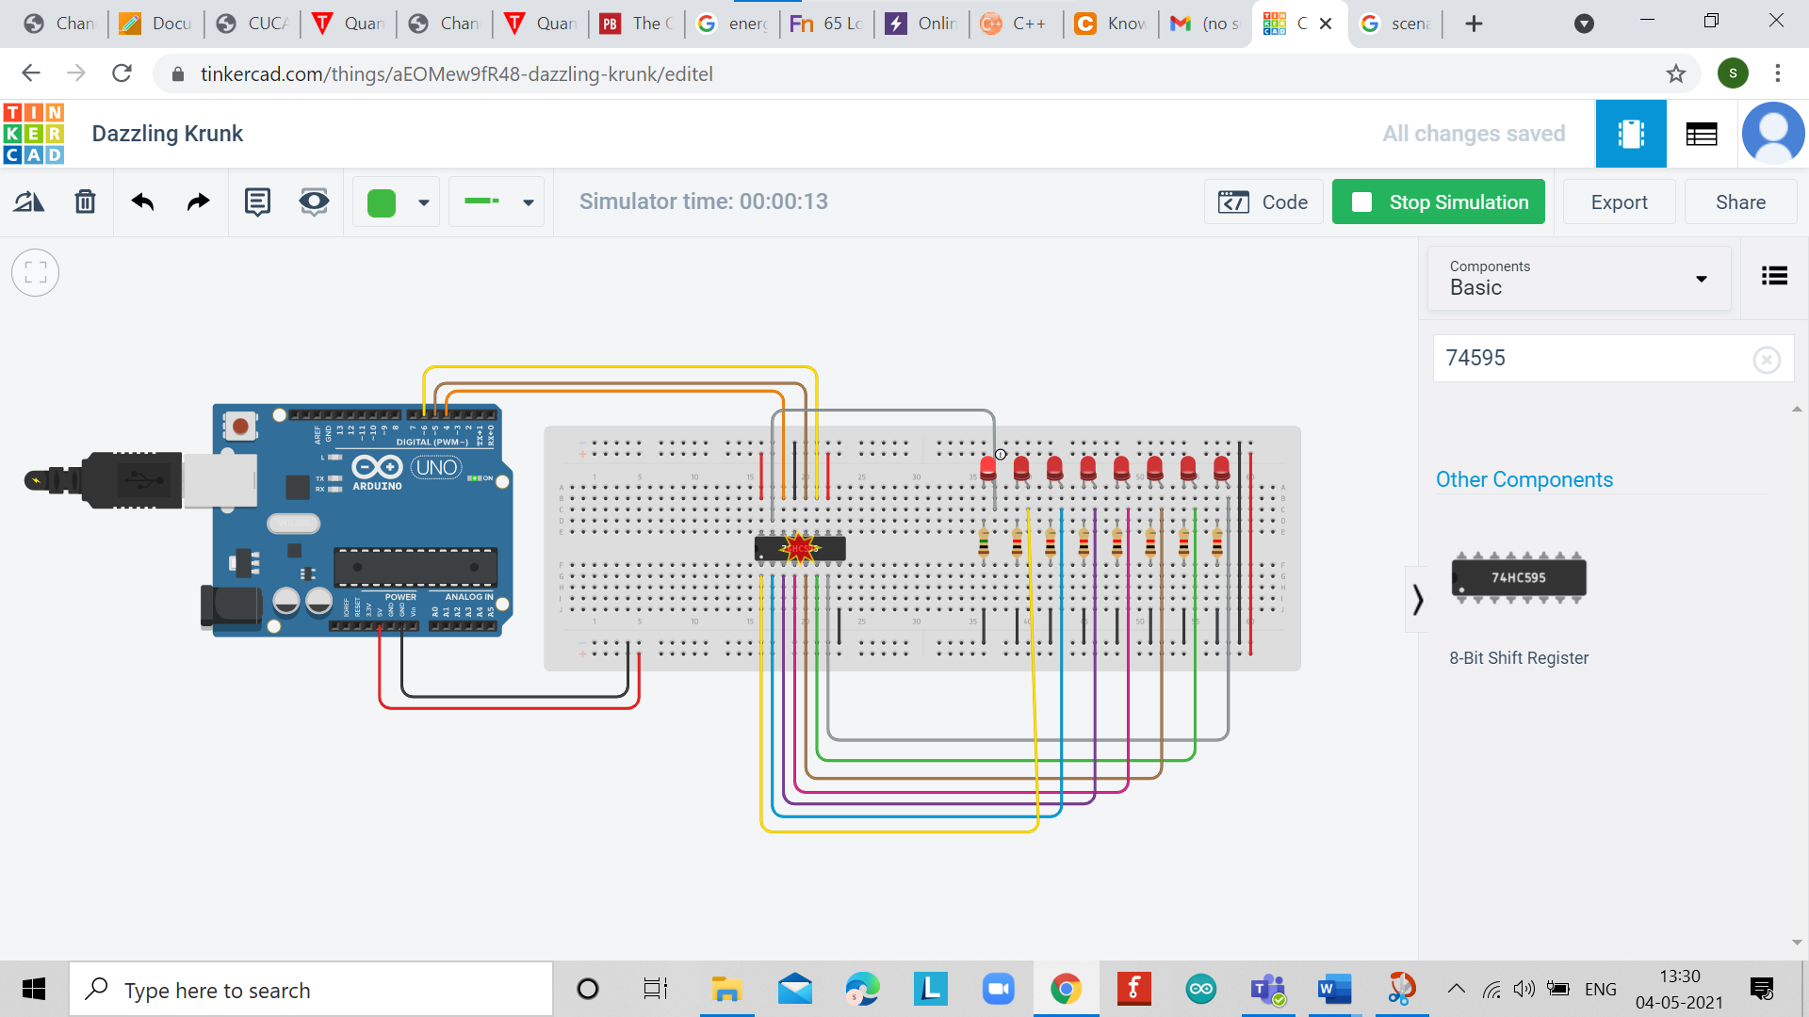

**Result:**

The Shift register has been designed and implemented using push buttons.